Practical 8
- Develop a program using malloc(), calloc(), realloc(), and free(). Monitor memory allocation behavior and identify memory leaks using Valgrind.

Develop a program that demonstrates Copy-on-Write behavior after a fork(). Analyze memory usage before and after modifying data in the child process.
Sol:-
1)mem_alloc.c
#include <stdio.h>
#include <stdlib.h>

int main() {
int *arr, *new_arr;
int n = 5;

arr = (int *)malloc(n * sizeof(int));
if (!arr) return 1;
printf("malloc allocated %d integers\n", n);

int *carr = (int *)calloc(n, sizeof(int));
if (!carr) { free(arr); return 1; }
printf("calloc allocated %d integers (initialized to 0)\n", n);

new_arr = (int *)realloc(arr, 10 * sizeof(int));
if (!new_arr) { free(arr); free(carr); return 1; }
arr = new_arr;
printf("realloc resized array to 10 integers\n");

for (int i = 0; i < 10; i++) {
arr[i] = i * 10;
printf("arr[%d] = %d\n", i, arr[i]);
}

free(arr);
free(carr);
printf("Memory freed successfully\n");
return 0;
}
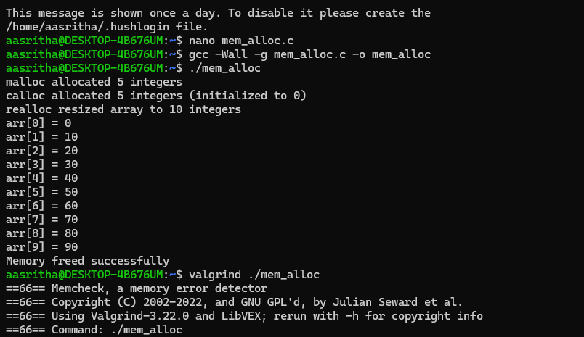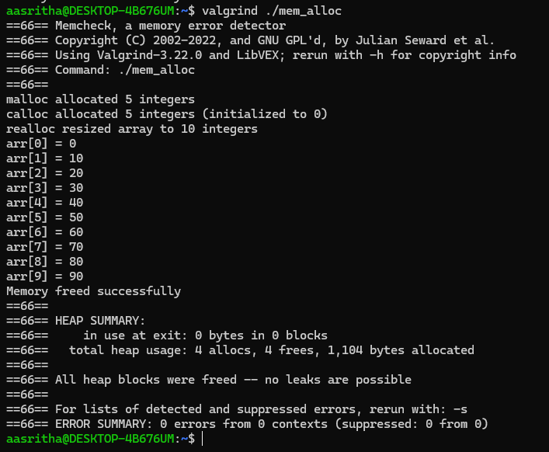

2) cow.c
#include <stdio.h>
#include <stdlib.h>
#include <unistd.h>

int main() {
int *shared = malloc(sizeof(int));
if (!shared) return 1;
*shared = 42;

printf("Parent before fork: shared=%d, addr=%p\n", *shared, (void*)shared);

pid_t pid = fork();

if (pid < 0) {
perror("fork failed");
free(shared);
return 1;
} else if (pid == 0) {
printf("Child before modification: shared=%d, addr=%p\n", *shared, (void*)shared);
*shared = 99;
printf("Child after modification: shared=%d, addr=%p\n", *shared, (void*)shared);
free(shared);
} else {
sleep(1);
printf("Parent after child modification: shared=%d, addr=%p\n", *shared, (void*)shared);
free(shared);
}
return 0;
}
